24. Simulation of Plane Strain (Shear Box)

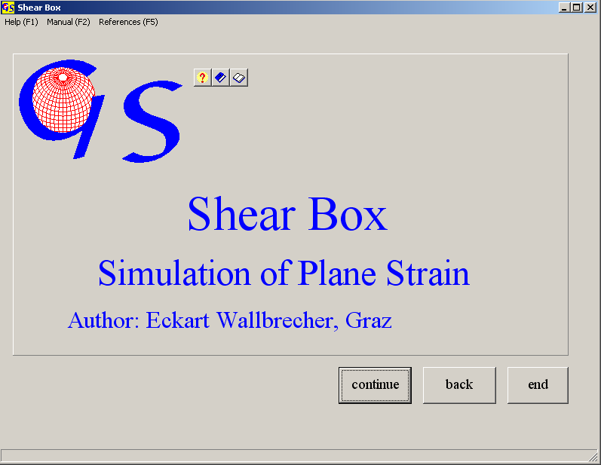
Fig. 1

This program simulates plane strain deformation (shearing and flattening) on various markers.

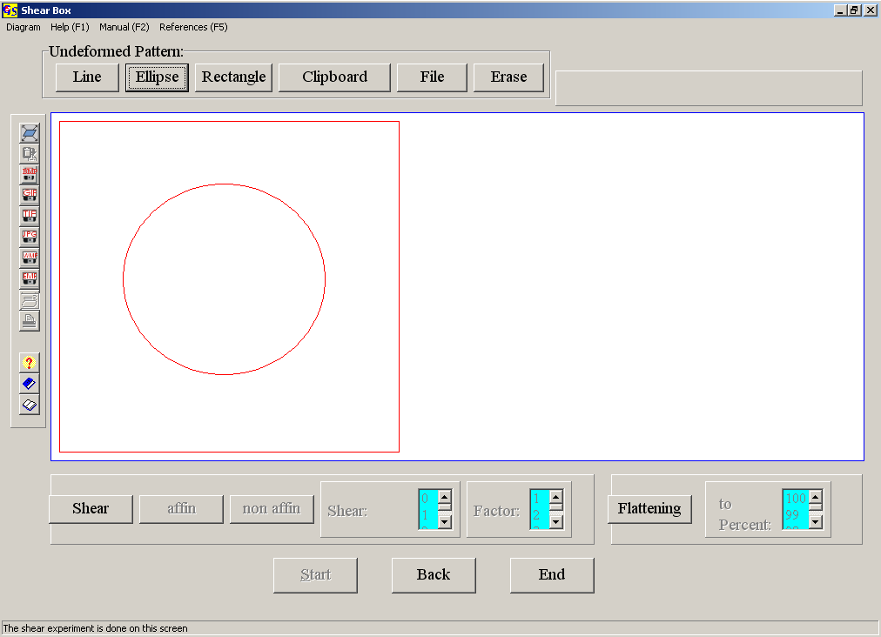
Fig. 2

In Fig. 2 a circle is drawn after clicking on the button "Ellipse".

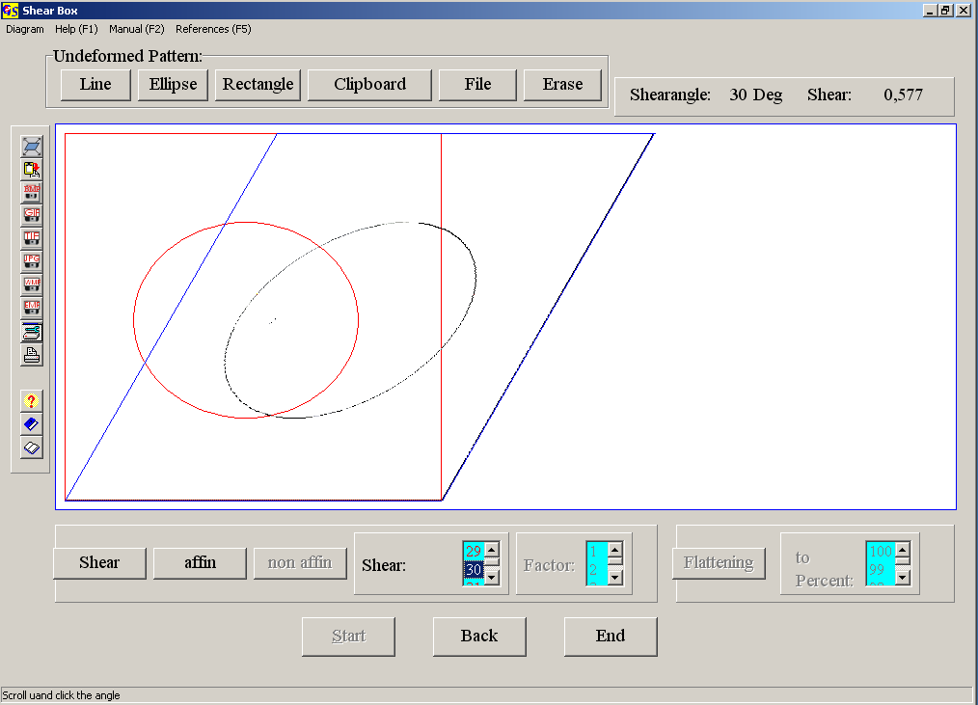
Fig. 3

Fig. 3 shows the deformation of this circle after clicking on „Shear“ and „affine“ and after selection of a shear angle of 30°.
Fig. 4 shows the deformation of a bitmap which was imported by clicking on the button “file”. You may also use a bitmap from the clipboard. The format must be “.bmp”.
Fig. 5 shows a non affine (inhomogenous) deformation of this bitmap. Shear strain increases to the margin, controlled by a factor. Fig 6 shows flattening strain with shortening in vertical direction to 50% of the original.

The options of the menu "Diagram" are explained in program 3.

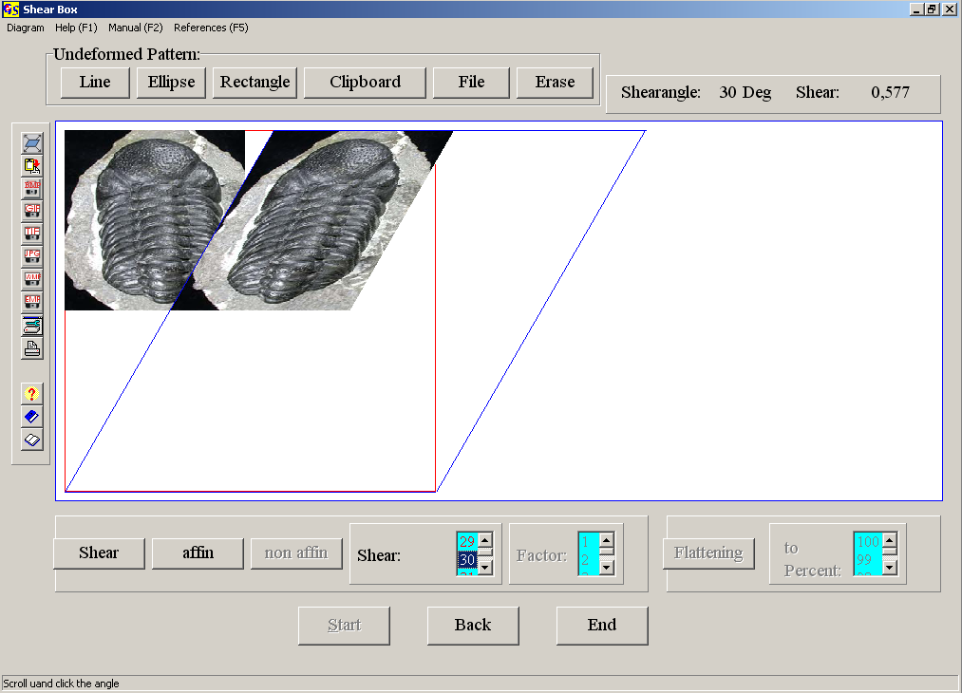
Fig. 4

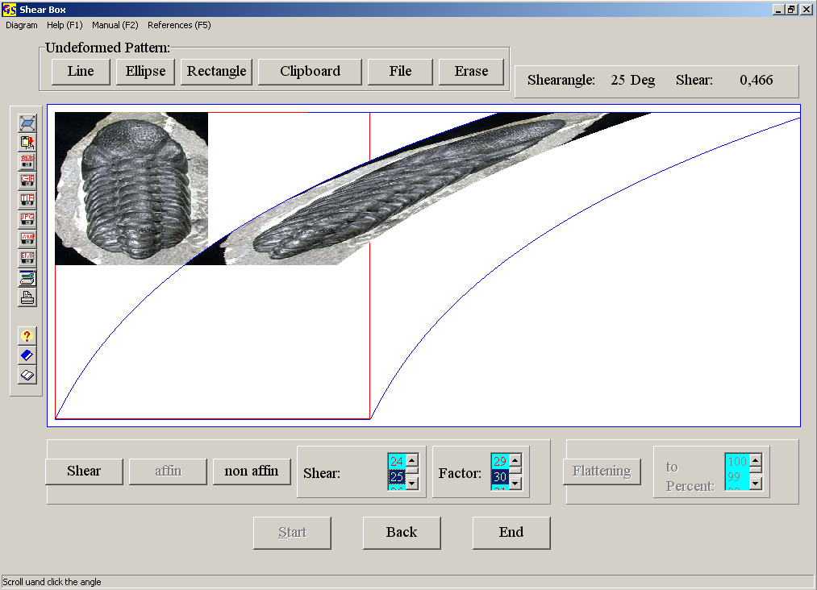
Fig. 5

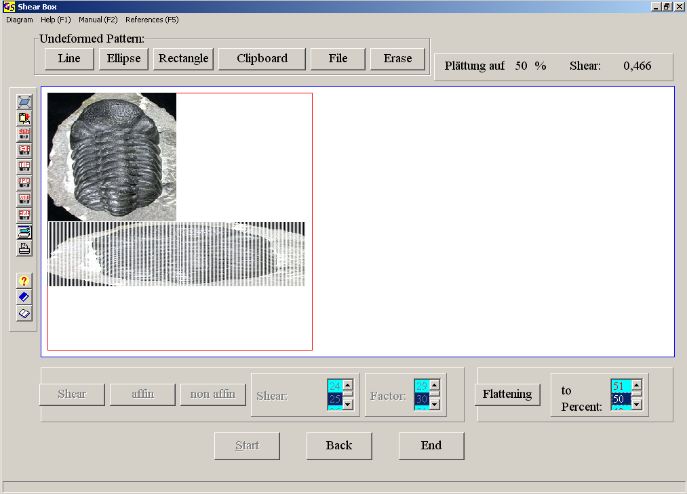
Fig. 6

